Step 0 Intake + Interview Filing Status, Dependency

Interview Notes: (See also: General Notes)
- George was a full-time student at a local college
- Mary paid $144 in Student Loan interest during the tax year
- The Browns paid $9,000 in rent while living in Dover through June (They had lived at the Dover address for many years)
- The Browns moved in July when they inherited a house in Denville. They paid $4,534 in property taxes, but had no mortgage payments. According to the postcard from the tax office: – Block=50001, Lot=00002, Qualifier is blank.
- Henry started receiving his pension from Fidelity this year
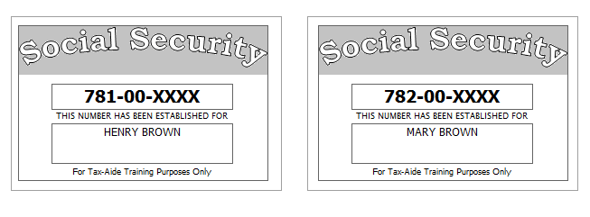
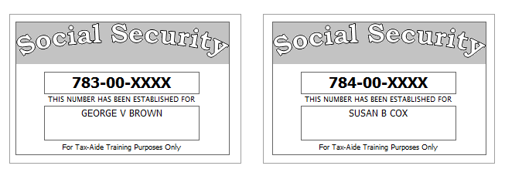

Step 1 Basic Information

TP Form / Note | TS Screen | Notes
 | Basic Information – Filing Status
Intake Sheet | What is your filing Status? | Select Filing status from drop down.  Answer: Filing Status: Married filing joint  Continue
SS Card  Intake Sheet  I-Note 1  G-Note 2 | Personal Information  Taxpayer Information  Spouse Information  Address & Phone Number | Hint: Use Name and SSN from SS card. (Not Intake Sheet)  Hint: SSN format YYY-00-0752  TS: Birth date can be entered using drop down menu or filling in the field.  TS: Check any of the “Check here” questions that apply –  TS: Spouses last name auto populates when field is selected. Change if required.  TS- Check presidential election campaign fund for SP  TS: Enter Zip code- TaxSlayer fills in city and state. Correct if required  TS: Enter New Jersey as the Resident State  TS: Select Continue
Intake Sheet  G-Note 2, 3 | Just a Few More Questions (NJ Info) | TS: Select Municipality from drop down menu (Listed by county). Start typing Morris to quickly scroll down  TS: Answer question regarding dependent Health Insurance. Answer is Yes.  TS: Select Yes or No for the Gubernatorial Election Fund. See Intake Sheet page 3 and General Note 3. No for TP, Yes for SP.  TS: Enter Five Digit Pin for TP and SP. Any 5-digit number.  TS: Select Continue
 | Dependents/ Qualifying Person  Do you have any Dependents or Qualifying Person(s) to claim on your return? | TS: Answer is “Yes”.
 | Dependent/Qualifying Child  Information | Add dependent information  Hint: Use name and SSN from SS card (Not Intake Sheet)  Answer: SSN format = YYY-00-0752  Check the “Check if” questions that apply  Answer: Both dependents are full time students, but only George is over 18  Add second dependent information  Hint: Susan’s last name is Cox. Make the change.  TS: Select “Continue”

Federal Refund: 0 NJ Refund Amount: 0

Step 2 SSA-1099
TP Form / Note | TS Screen | Notes
SSA-1099 | Federal Section  Let’s look at the money You earned  Enter Myself  Income  IRA/Pension Distribution Form 1099-R/RRB/SSA  - Begin  Social Security Benefits/RRB-1099 -Begin | Enter SSA-1099 Data  Hint: Use TP4F Scratch Pad to document Medicare Parts B, C, D. Insert total in “Taxpayer’s Medicare Premiums”. Amount = $1889  TS: Continue, Continue

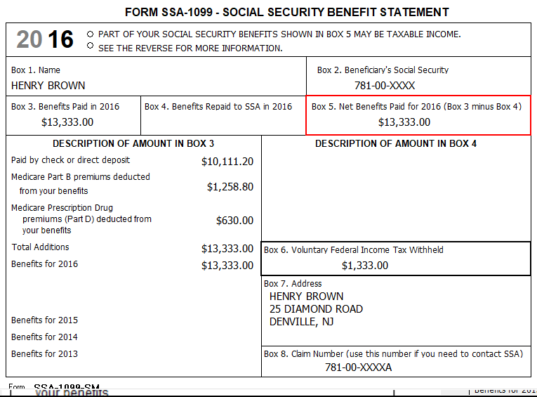

Federal Refund: 1,333 NJ Refund Amount: 0

Step 3 W-2 Green Grass Golf
W-2  Green Grass Golf | Income  Wages & Salaries Form W-2  Begin | Hint: Henry Brown W-2  Hint: Make corrections so that information matches the information on the W-2  Hint: If the name and address of the employer come up after inputting the employer Identification Number, check that the information is correct  Hint: Always round up for amounts ending in --.50  Hint: Box 14 NJ Codes are selected from drop down menu. All other entries in box 14 are lumped under “Other”  Hint: If NJ State EIN auto populates, check to be sure it is correct  TS: Click continue NJ warning  TS: Click Continue
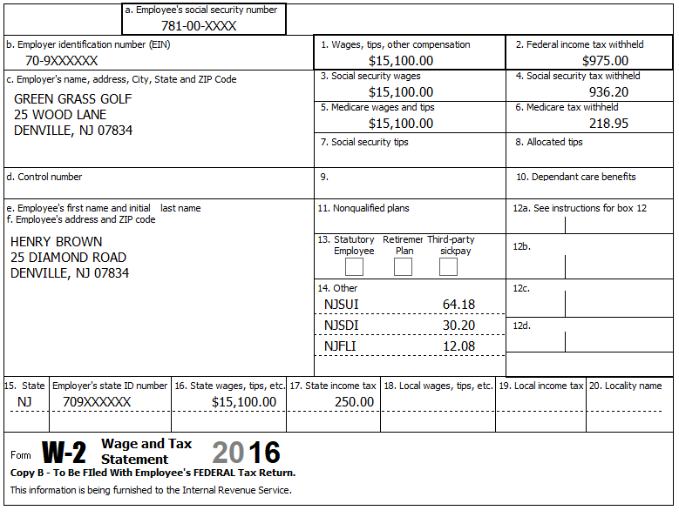

Federal Refund: 7,880 NJ Refund Amount: 2,200

Step 4 W-2 Joe’s Bar & Grill
TP Form / Note | TS Screen | Notes
W-2 Joe’s Bar & Grill | Add W-2 Statement | Hint: W-2 for Mary Brown  Hint: Make corrections so that information matches the information on the paper W-2  - Change address on TS W-2 to match paper W-2  Hint: If the name and address of the employer come up after inputting the employer Identification Number, check that the information is correct  TS: Certain characters are not allowed for E-File (#, ‘). TS will remove them once the form is saved  Hint: Check boxes 3-7 for correct entries  Hint: Always round up for amounts ending in --.50  Hint: Box 14 NJ Codes are selected from drop down menu. All other entries in box 14 are lumped under “Other”  Hint: If NJ State EIN auto populates, check to be sure it is correct  TS: Click continue NJ warning  TS: Click Continue

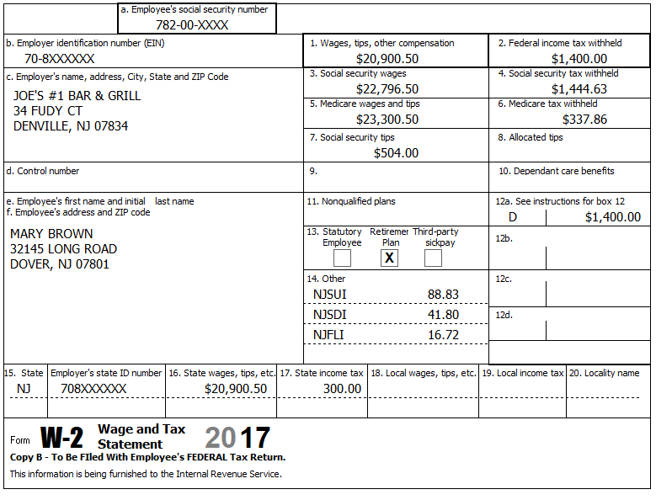

Federal Refund: 4,589 NJ Refund Amount: 770
Step 5 Interest 1099-INT
TP Form / Note | TS Screen | Notes
1099-INT  National City Bank | Income  Interest Income, Form 1099-INT/ 1099-  DIV- Begin  Interest or Dividend Income -Begin  Interest Income, Form 1099-INT,Form  1099-OID…..  Continue | Hint: Select for Taxpayer  Enter values that apply  Continue

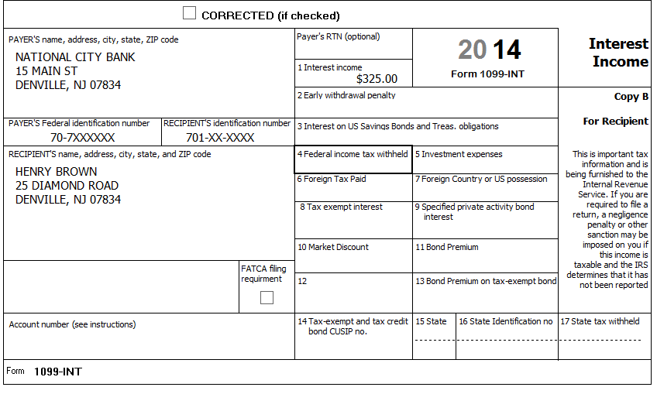
2016

Federal Refund: 4,433 NJ Refund Amount: 726

Step 6 Dividends 1099-DIV
TP Form / Note | TS Screen | Notes
1099-DIV  Dreyfus | Add an Interest and Dividends  Dividend Income, Form 1099-DIV  Continue | Hint: Select for Taxpayer  Enter values that apply  Continue Until Back to Income
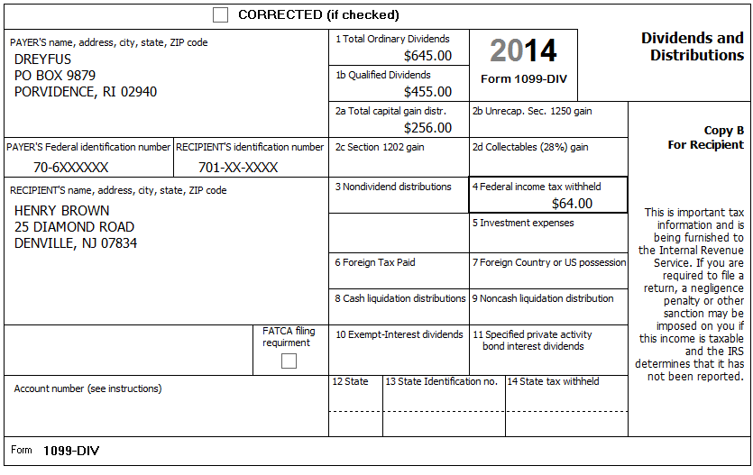
2016
781-00-XXXX
2016

Federal Refund: 4,148 NJ Refund Amount: 612

Step 7 1099-R

TP Form / Note | TS Screen | Notes
1099-R  Fidelity Investments | IRA/Pension Distribution Form 1099-R / RBA, SSA – Edit  Add or edit a 1099-R | Hint: “This 1099-R is for Henry  Hint: Make corrections so that information matches the information on the 1099-R  Hint: Taxable amount defaults to Gross Distribution Amount. Adjust as required.  TS: You do not have to select a State for income to go to the State return.  TS: Continue back to Income
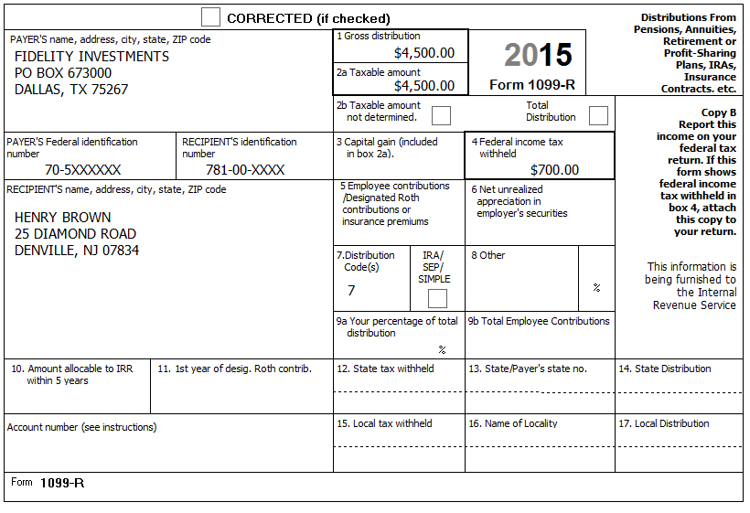
2016
Federal Refund: 2,291 NJ Refund Amount: 94

Step 8 Unemployment 1099-G

TP Form / Note | TS Screen | Notes
1099-G  NJ Dep of Labor | UnemploymentCompensation Form 1099-G Box 1 – Begin  Add or Edit a 1099-G - Begin | TS: This 1099G worksheet is for the: Spouse  Hint: Phone number not required  Hint: State information not required  Continue
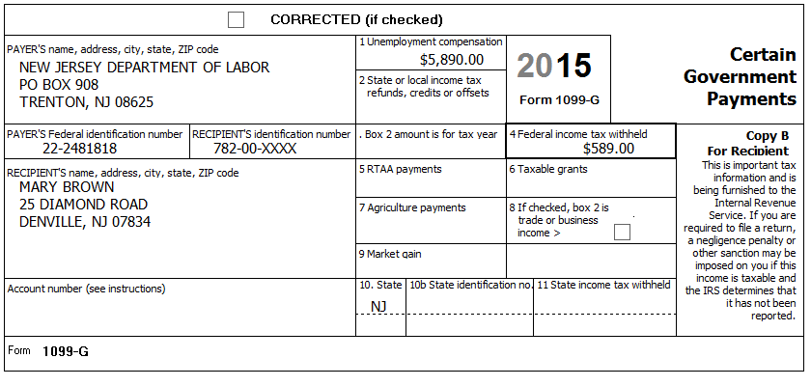
Federal Refund: 1,762 NJ Refund Amount: 94
Step 9 Student Loan Interest
TP Form / Note | TS Screen | Notes
I-Note 2 | Left Menu  Federal Section – Deductions  Enter Myself  Adjustments - Begin  Student Loan Interest Deduction - Begin | Enter Student Loan Interest Amount  Continue to Deductions

Mary paid $144 in Student Loan interest during the tax year

Federal Refund: 1,785 NJ Refund Amount: 94
Step 10 Itemized Deductions – Taxes You Paid
TP Form / Note | TS Screen | Notes
I-Note 4 | Federal Section -Deductions – Itemized Deductions – Begin  Taxes You Paid - Begin | Enter real estate taxes paid  Go to the Sales Tax Worksheet and enter NJ AND 366 days living in NJ  Continue Until Health Insurance Introduction

The Browns moved in July when they inherited a house in Denville. They paid $4,534 in property taxes, but had no mortgage payments.

Federal Refund: 1,785 NJ Refund Amount: 94
Step 11 Compare Standard vs Itemized Deductions

TP Form / Note | TS Screen | Notes
 | Federal Section  Deductions  Enter Myself  Compare Deductions - Begin | Check to see if using itemized or standard deductions.  Itemized = 5,392  Std = 13,850  Continue

Federal Refund: 1,785 NJ Refund Amount: 94
Step 12 Health Insurance

TP Form / Note | TS Screen | Notes
G-Note 2 | Left Menu  Health Insurance  Start Questionnaire | Answer questions in the Health Insurance Section

Every person on the return had health insurance that met Minimum Essential Coverage rules for the entire year. They did not purchase it through the marketplace.

Federal Refund: 1,785 NJ Refund Amount: 94

Step 13 New Jersey Return

TP Form / Note | TS Screen | Notes
I-Note 3 & 4  G-Note 2,3,4 | State Return –Edit  Enter Myself  Basic Information  Credits  - Property Tax/Deduction-Begin | Hint: Use the NJ Checklist to enter NJ items  HINT: Check Basic Information – Default values will not appear as selected  Hint: Use scratch pad at TP4F to determine the proper value for Property Tax Paid  Hint: Property Taxes Paid = (rent*.18) + Property taxes paid  - (9,000*.18) + 4,534 = $6,154  Hint: Taxpayer meets Property Tax Eligibility Requirements  Hint: Enter the Block and Lot numbers  Hint: County Property Located in Denville.  Continue back to the beginning of the State Return

The Browns paid $9,000 in rent while living in Dover through June (They had lived at the Dover address for many years)
The Browns moved in July when they inherited a house in Denville. They paid $4,534 in property taxes, but had no mortgage payments. According to the postcard from the tax office: – Block=50001, Lot=0002, Qualifier is blank.
They had no out-of-state purchases on which they did not pay Use tax

Federal Refund: 1,785 NJ Refund Amount: 201

Step 14 Prepare for e-file

Intake Sheet  G Note 5 | Left Menu – e-file – | TS – Clear up any diagnostic messages (if any)  TS: Select Federal Return Type “E:file: Direct Deposit”  TS: No entries in Fees section except for Client email address  TS – Pin numbers for e-file are automatically selected  TS: Select State Refund Type “E:file: Direct Deposit”  TS: Enter Bank Information – Name of Bank not required  TS: Skip Third Party Designee Info  TS – Questions – Answer questions from Intake sheet Part VII, lines 5.6 and 7, Supplemental Intake Sheet,  TS: Skip TP ID Information Screen  Save  You are Done

They want to handle any state refund / amount due like their federal refund / amount due

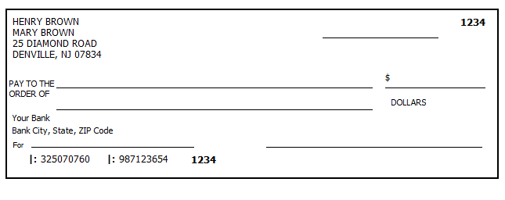

Federal Refund: 1,785 NJ Refund Amount: 201

